* **Successfully installed Cent OS7 on four virtual machines.**

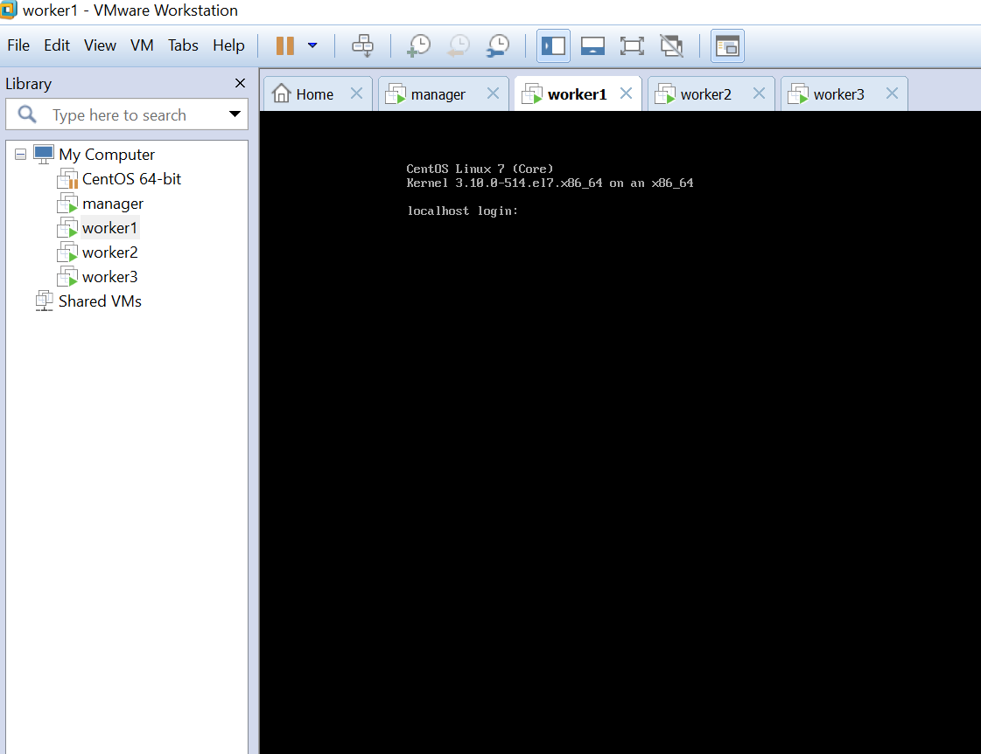

* **Successfully pinged each cluster machine from manager node.**

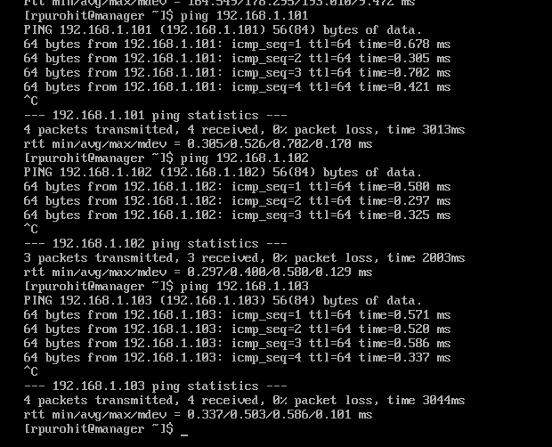

* **Successfully logged into cluster via Putty**

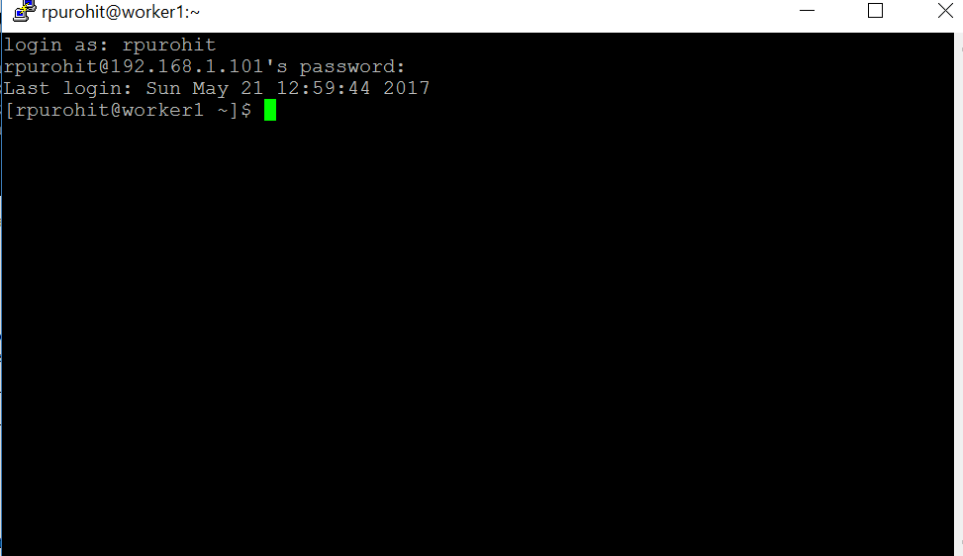

* **Succesfully updated OS on each cluster machine**

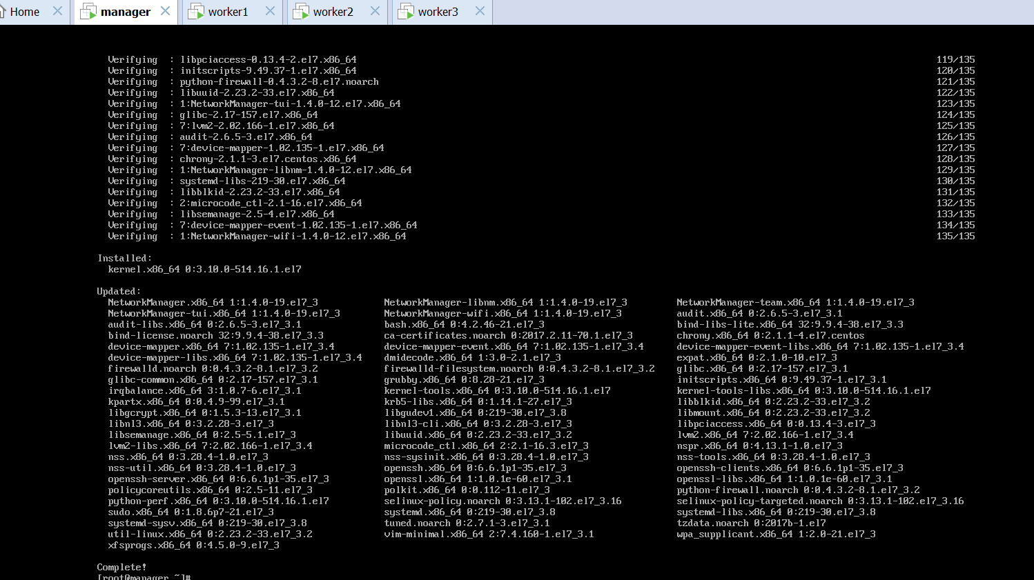

* **Succesfully installed nano**

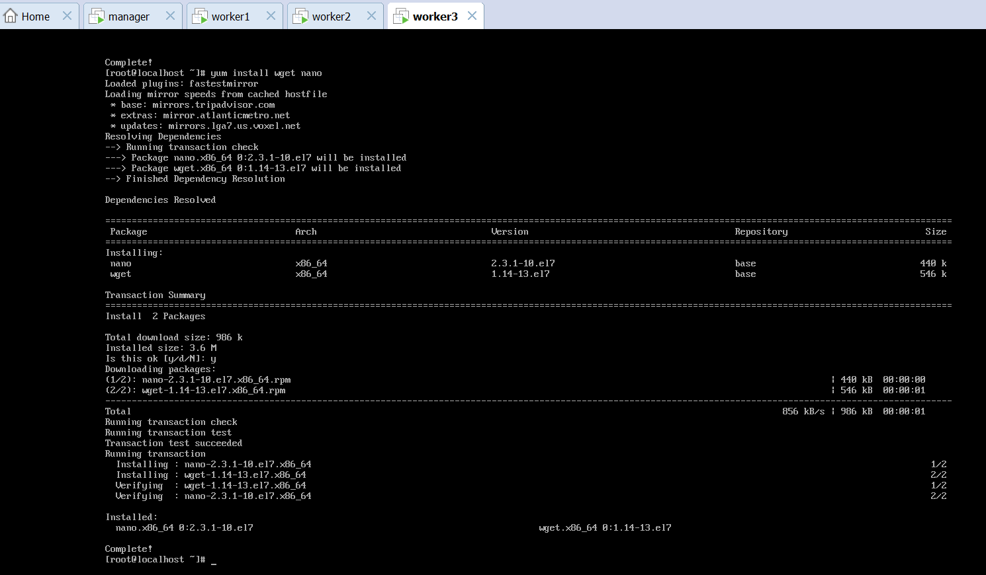

* **Successfully installed java**

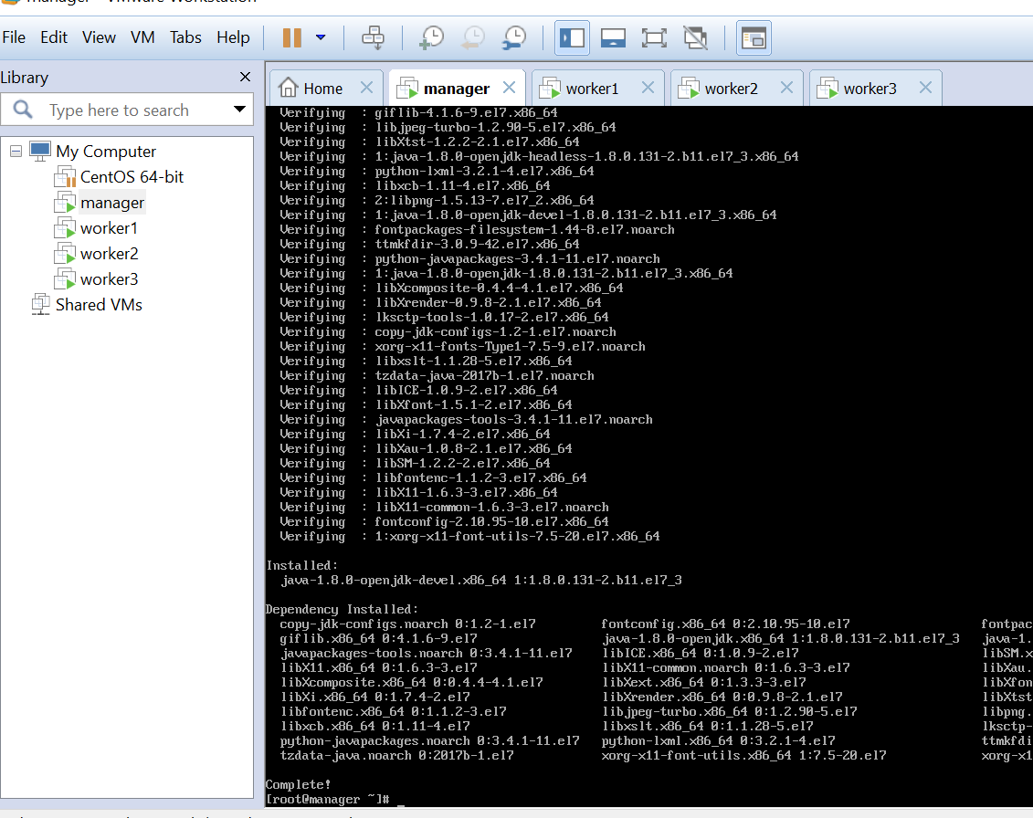

* **Successfully edited the /etc/hosts entries for manager node**

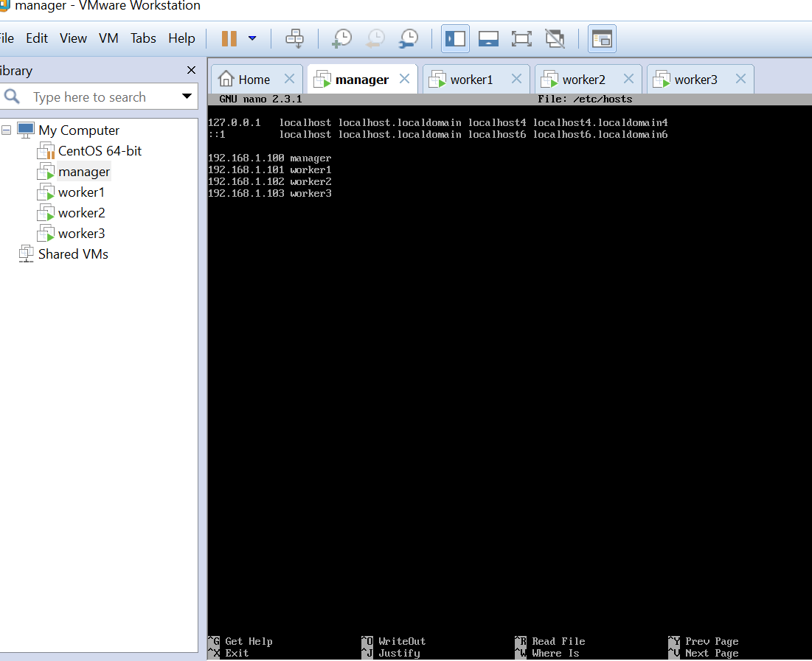

* **Succesfully ssh’d into worker1, worker2, worker3 nodes from manager node**

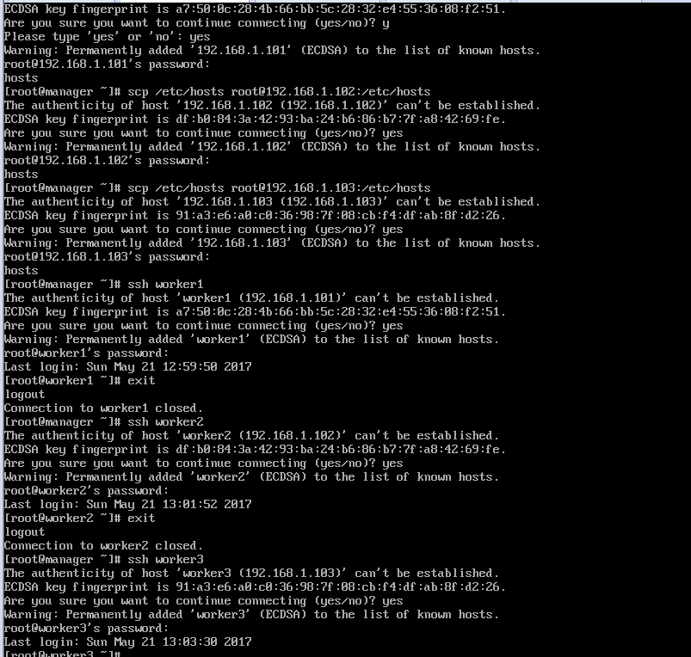

* **Succesfully added Hadoop username and password to each node**

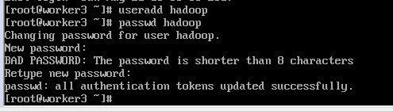

* **Succesfully formatted name node**

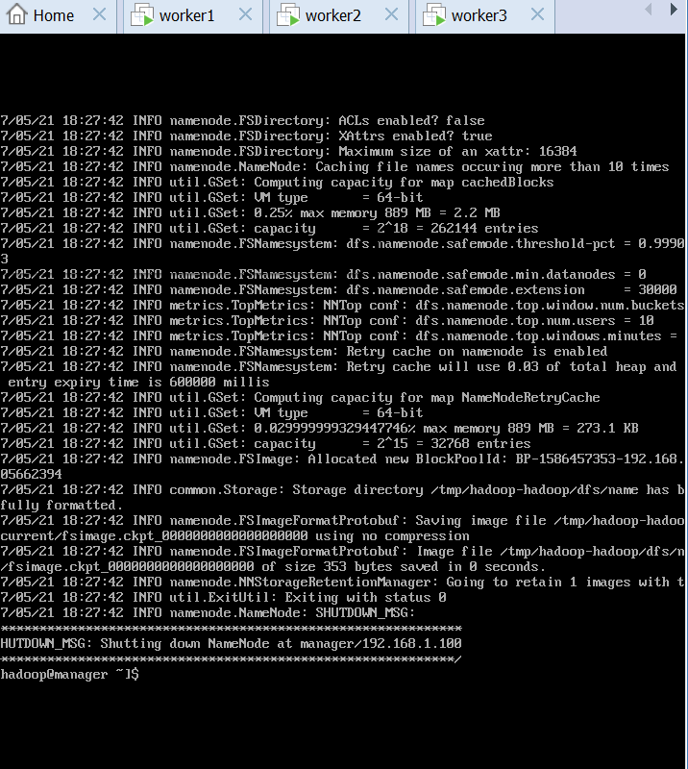

* **Succesfully checked Java processes for Hadoop map reduce :**

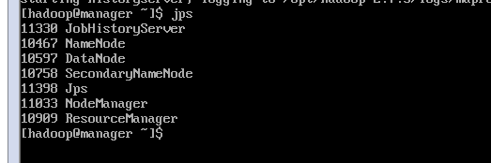

* **Succesfully created directories and executed map reduce job**

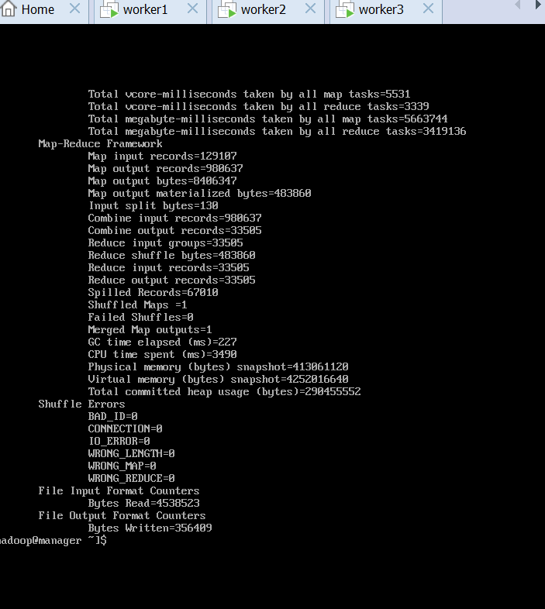

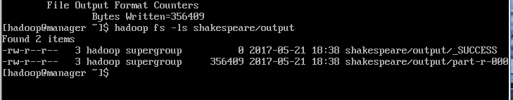

* **Output of Map reduce:**

